BATCH ID: B10-4A6E

ROLL NO: 1902027

NAME: DHARSANA K

CODE:

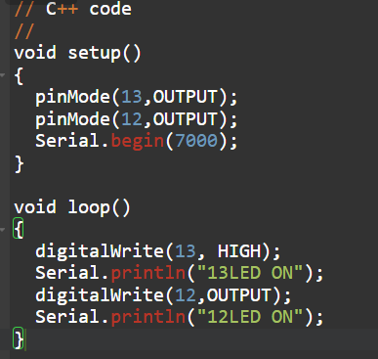

SIMULATION:

